{JIRA Case: <http://jira.pentaho.com/browse/DOC-2841>}

{iWiki Content: <http://iwiki.pentaho.com/pages/viewpage.action?pageId=23856163>}

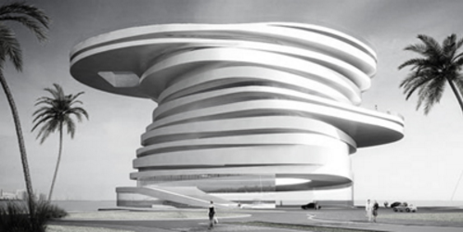

The Shape of Things to Come

Here is where we can put pictures of architecture and modeling discussions, as well as examples or drawings.

# Highest Level of Model Openness

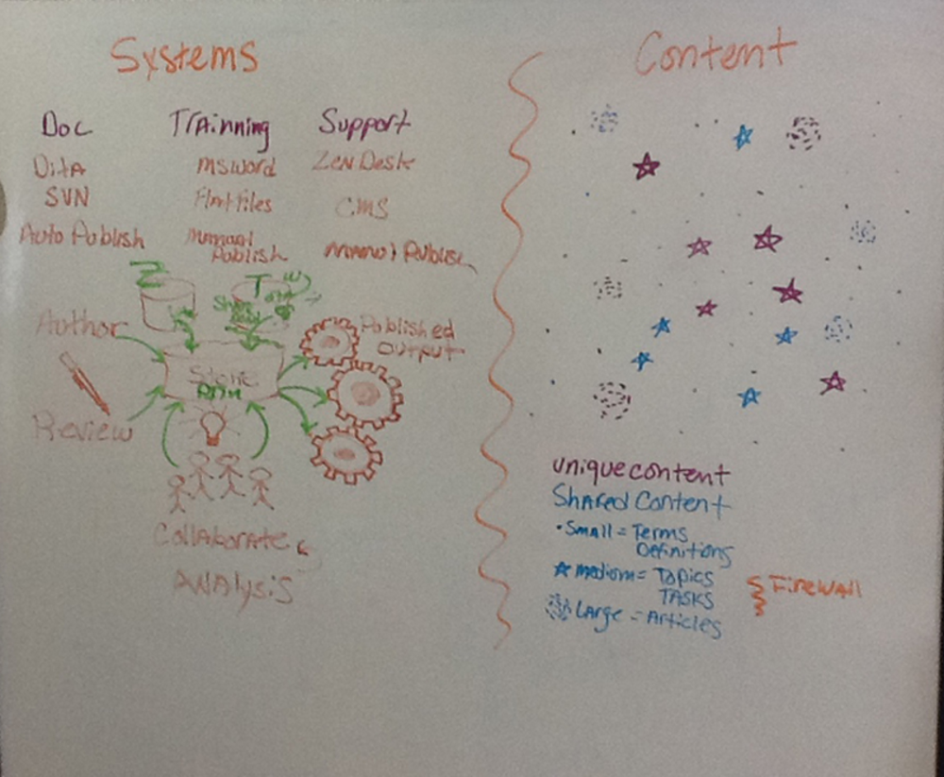

# Pyramid and Opening Up the Monolith

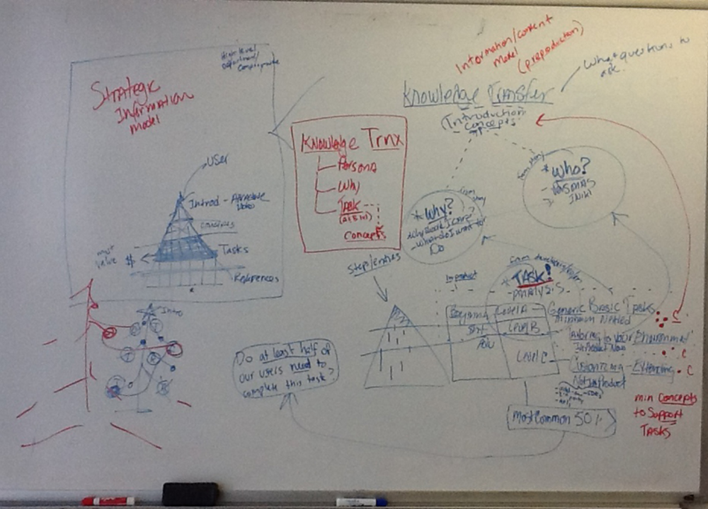

# More Pyramid

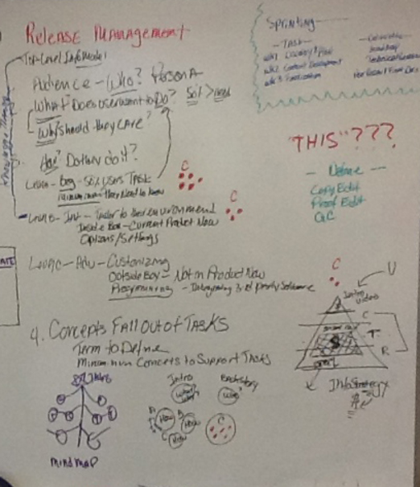

# Article Content Models

Please refer to these topics to see how each content model is structured, the language we use for the components of the model, and to get ideas about how to use the model.

* **Introductions to content sequences, or guides as we knew them, includes a section that announces the purpose of this content sequence, what you do in this sequence and headings that announce pre-requisites, expertise, tools, and other interesting high-level things about this content sequence.**  
  <http://infocenter-qa.pentaho.com/help/topic/config_ba_server/concept_config_ba_intro.html>
* **Guideposts** for complex articles that span several sub-articles.  
  <http://infocenter-qa.pentaho.com/help/topic/config_ba_server/concept_config_ba_server_intro.html>
* **Article introductions** include a mini TOC for that article and refer to the guidepost stops to remind people to go on to the next stop. This way we nudge readers along and keep them inside the happy path.  
  <http://infocenter-qa.pentaho.com/help/topic/config_ba_server/task_starting_ba_server.html>
* **Decision topics with tables** show the options and details about making a choice. We include time and expertise as decision drivers and provide recommendations. These topics have a standard taxonomy that enables searching for “decision table” to find all the decision points in the topics we have written thus far. This will eventually be included throughout all content, enabling readers in the planning phase to see all the decisions they can make in the development and production life-cycles.  
  <http://infocenter-qa.pentaho.com/help/topic/config_ba_server/topic_about_data_connections.html>
* **UI element tour topics** include a screen shot with little numbered dots on it to focus readers attention at particular points of interest in the UI. These numbers are then noted in a table where each numbered dot representing a point in the UI is discussed and explained.  
  <http://infocenter-qa.pentaho.com/help/topic/config_ba_server/task_authenticating.html>

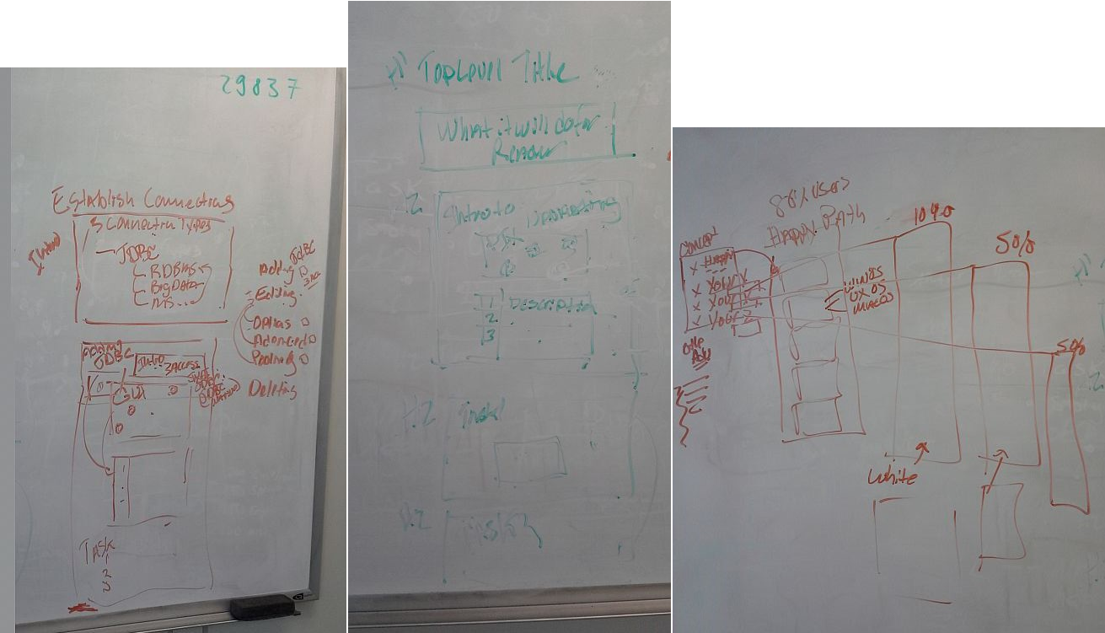

# Choice Model and Big Picture

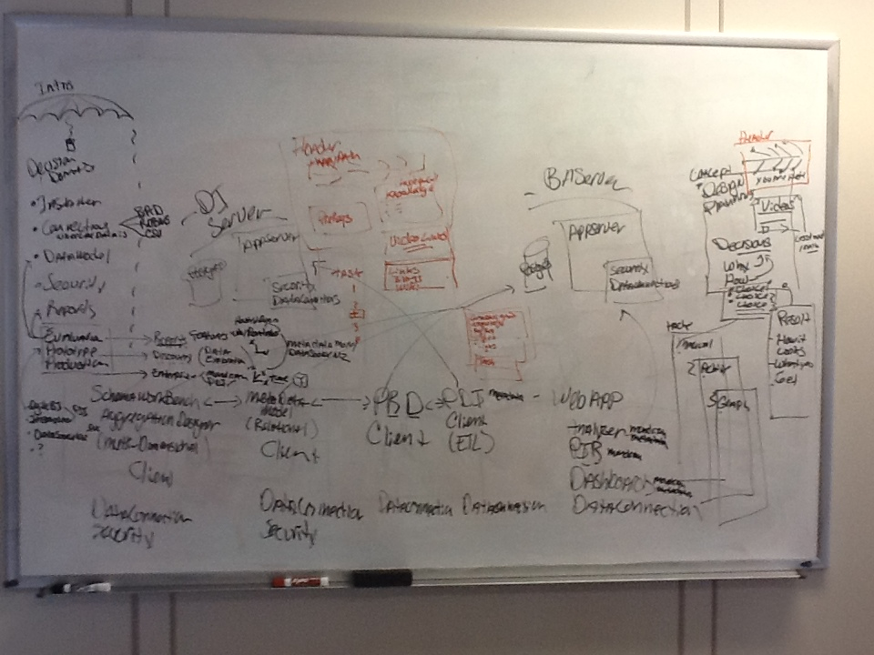

# Models for Variants like Mac, UX, Win

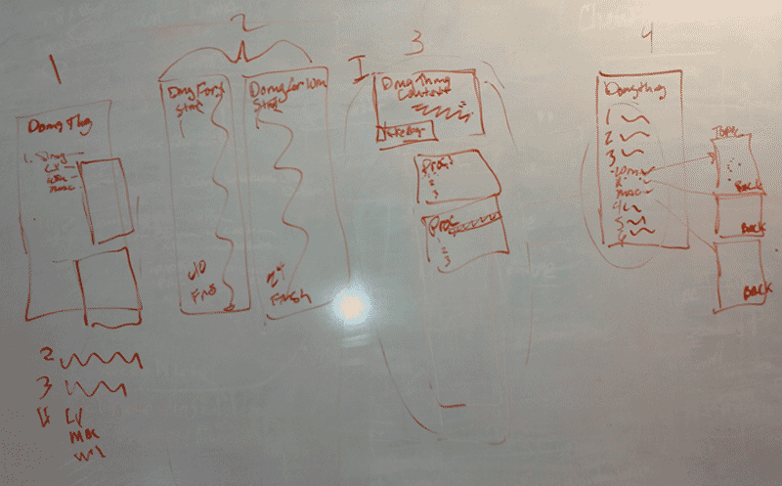

{MindTouch Content: <https://help.pentaho.com/UX_and_Documentation_Home/Documentation_Style_Guide/Content_Types>}

Content Types

# Article Content Models in DITA (2013)

Please refer to these topics to see how each content model is structured, the language we use for the components of the model, and to get ideas about how to use the model.

* **Introductions to content sequences, or guides as we knew them, includes a section that announces the purpose of this content sequence, what you do in this sequence and headings that announce pre-requisites, expertise, tools, and other interesting high-level things about this content sequence.**  
  [**http://infocenter-qa.pentaho.com/help/topic/config_ba_server/concept_config_ba_intro.html**](http://infocenter-qa.pentaho.com/help/topic/config_ba_server/concept_config_ba_intro.html)
* **Guideposts** for complex articles that span several sub-articles.  
  <http://infocenter-qa.pentaho.com/help/topic/config_ba_server/concept_config_ba_server_intro.html>
* **Article introductions** include a mini TOC for that article and refer to the guidepost stops to remind people to go on to the next stop. This way we nudge readers along and keep them inside the happy path.  
  <http://infocenter-qa.pentaho.com/help/topic/config_ba_server/task_starting_ba_server.html>
* **Decision topics with tables** show the options and details about making a choice. We include time and expertise as decision drivers and provide recommendations. These topics have a standard taxonomy that enables searching for “decision table” to find all the decision points in the topics we have written thus far. This will eventually be included throughout all content, enabling readers in the planning phase to see all the decisions they can make in the development and production life-cycles.  
  <http://infocenter-qa.pentaho.com/help/topic/config_ba_server/topic_about_data_connections.html>
* **UI element tour topics** include a screen shot with little numbered dots on it to focus reader’s attention at particular points of interest in the UI. These numbers are then noted in a table where each numbered dot representing a point in the UI is discussed and explained.  
  <http://infocenter-qa.pentaho.com/help/topic/config_ba_server/task_authenticating.html>

Each of these could be based on their respective templates:

1. Reference: **Introduction / Summary / Overview / Concept**
2. **Task / Workflows** (these are really just a series of tasks)
3. **Tour / UX Field Description / PDI Steps & Entries**
4. **API** articles

Types that we don't currently have but might want to consider:

1. FAQs
2. Glossary
3. Field Help topics (reference type/context sensitive help)

|  |  |  |  |
| --- | --- | --- | --- |
| **"Type"** | **Example Article(s)** | **Description** | **Keep?  Merge? Revamp?** |
| **Introduction** | [Introduction to the Manual Installation Process](https://help.pentaho.com/Documentation/6.0/0F0/0K0/000) | generally describes the prerequisites required to do something |  |
| **Summary/Overview** |  | Overview of a system or feature |  |
| **Task** | [Enhance the Look of Your Interactive Report](https://help.pentaho.com/Documentation/5.4/0L0/120/020/010) | Step-by-step instructions on how to do something. May also contain subtasks. |  |
| **Tour** |  | Graphical and tabular overview of a GUI. | this type could be merged with the UX / Field Description content type |
| **Workflow:** |  |  | (really a complex task) |
| *Installation* |  |  |  |
| *Config* | [Use PostgreSQL as Your Repository Database](https://help.pentaho.com/Documentation/6.0/0F0/0K0/040/0A0)  or  [Define Native (JDBC) Data Connections for the BA Server (old)](https://help.pentaho.com/Documentation/6.0/0H0/060/010/030/000) | Templated topic, heavily formatted  (code samples and tables, etc.)  or  Templated topic from 5.0 | Data Connections template needs a refresh. It hasn't been revamped since 5.0, and the old Onyx style is used in there for some reason |
| *Evaluation* | [Develop Your BA Environment (old)](https://help.pentaho.com/Documentation/6.0/0D0/1A0/020/010) | Templated topic, heavily formatted | desperately needs a refresh |
| **Reference:** |  |  |  |
| *API* | [Users and Roles for Pentaho Security](https://help.pentaho.com/Documentation/6.0/0R0/070/010/0D0/0O0) | Templated topic, heavily formatted (code samples and tables, etc.) |  |
| *Concept* |  | How and why features work together, e.g. SDR  Can also be something that needs some defining and explaining, or a combination of both types of things. |  |
| *PDI Step/Entry* |  | Template topic specific for providing reference info |  |
| *UX / Field Description* | [Visualizations for Analyzer](https://help.pentaho.com/Documentation/6.0/0L0/120/030/010) | Overview of a particular UX item(s), typically with a screen-cap and a table covering the fields. |  |
| *Decision article* | [Introducing Pentaho Workflows and Tracks](https://help.pentaho.com/Documentation/6.0/0D0/1A0/000) | Article describing some related concepts along with a table guiding the user towards an option | This format can probably go away |
| *Support Matrix* |  |  |  |
| **Support Statement** |  |  |  |
| **Checklist** |  |  |  |
| **Troubleshooting** |  |  |  |

## Basics

### Concepts

* Overview (Overview vs. Introduction)
* About (true concept)

### Tasks

* Process
* Procedure

### Reference

* Ex. API
* Glossary
* Window (UI overview?)

## Some Specifics

* **Task** (step by step topics with numbered lists, notes, tips, stem sentences)
  + **Subtask** (same as above but maybe smaller or more generic, like “Opening a Thing” or “Selecting Ys for X”)
* **Workflow** (process topics which often incorporate explanatory text and a string of tasks with links, i.e. our topics using the bus stop graphic)
* **Summary/Overview** (overview of a system or feature with navigation to related topics.)
* **Reference** (Information on something. I defined possible subtypes for Reference)
  + **Window/Interface/GUI** (provides an overview of the layout of an area of the system, such as using an image with callouts and a table defining the areas called out)
  + **Concept** (how features work together and the goals of using them together, e.g. SDR. Also, something that might need some defining and explaining. Probably a combination.)
  + **PDI Step/Entry Topic** (template topic specific to providing reference info, but not really a task.)
  + **Any Field/Description** table topic
  + **API Topic** (template topic, heavily formatted)

Other Possible Ones (we may or not be using:)

* **Field Help** topics if we ever have context sensitive help on a field. Reference type.
* **Glossary** topic
* **New System Feature** document. Might be more of a document type.
* **Troubleshooting** topic/section
* **FAQs**

{Proposed New Section under <http://iwiki.pentaho.com/display/DOC/Standards>}

Content Types

The following content types occur in our MindTouch Help site:

* Introduction/Overview/Summary
* Task
* Tour
* Workflow
* Reference
* Support Statement
* Checklist
* Troubleshooting

# Introduction/Overview/Summary

Description of a system or feature, and might include the following items:

* Prerequisites (in a “Before You Begin” section)
* Description of the audience
* General use cases
* Related sections or articles

# Task

Step-by-step instructions on how to do something. It may also contain subtasks.

# Tour

Graphical and tabular overview of an application describing each element of the application, such as menu items, toolbars, panels, etc.

# Workflow

A complex task described over many articles, as shown by the following examples:

* Installation
* Configuration – heavily formatted (code samples and tables, etc.)
* Evaluation – heavily formatted

# Reference

Easily accessed source of information for a reader who already understands the related system or feature. Our documentation has the following specific types of references:

* API
* Concept
* PDI Step/Entry
* GUI/Field Description
* Decision
* Support Matrix

## API (Application Program Interface)

The programmatic calls used to access various interfaces within the Pentaho suite. Most of this MindTouch content is generated directly from comments within the API code. If additional information needs to be added after the MindTouch content is generated, you need to verify this additional information with the code that is stored in GitHub.

## Concept

How and why features work together (SDR for example). Can also be something that needs some defining and explaining, or a combination of both types of things.

## PDI Step/Entry

PDI (Pentaho Data Integration) contains ETL (Extract, Transform, and Load) data functions. The ETL functions used in a Transform (data flows) are known as Steps. The functions used in a Job (workflows) are known as Entries.

## GUI/Field Description

Overview of a particular GUI (Graphical User Interface), typically with a screen-cap and a table covering the fields.

## Decision

Related concepts along with a table guiding the user towards specific options.

## Support Matrix

A table indicating what components are supported by Pentaho per specified versions of products or other components.

# Support Statement

{?}

# Checklist

A table of requirements needed to progress through a workflow. This table usually includes links to tasks describing how to perform what is needed for each requirement.

# Troubleshooting

Sections describing the known issues and solutions for how to working around them.